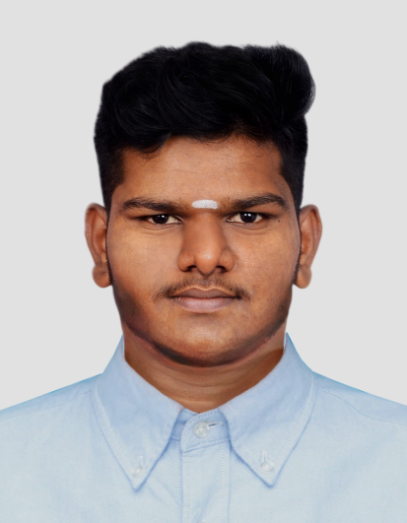
MUGESH R

6381323029
E-mail Id: mugeshr03310@gmail.com
LinkedIn Id: .linkedin.com/in/mugesh-r-106606249/

CAREER OBJECTIVE:
Hard-working, team player seeking an opportunity to incorporate my skills to develop myself as well as organisation
ACADEMIC QUALIFICATION:

COURSE | INSTITUTION | BOARD/  UNIVERSITY | PERCENTAGE/ CGPA | YEAR OF PASSING
B.E  Computer  Science  Engineering | Karpagam  Academy of  Higher  Education | Deemed  University | 6.1  (Till 4th sem) | 2025
H.S.C | S.K.G.  Higher Secondary School | State Board | 78% | 2021
S.S.L.C | S.K.G.  Higher Secondary School | State Board | 71% | 2019

AREA OF INTEREST:

Software developing
Web Designing

TECHNICAL SKILLS:
HTML/CSS
C Programing Language
JAVA Programing Language
PYTHON Programing Language

PROJECT:
Service hub (people to connect labour)
Abstract : The project help the householders to fix the appointment for household repairs it is created by using the frontend tools as HTML,CSS and backend tool as SQL
LINKS:
Github id: https://github.com/Mugeshking33
leetcode id:https://leetcode.com/mugeshking33/
CodingNinjas:https://www.codingninjas.com/studio/profile/
e60b87ae-5d40-49f3-ac01-bfc089726999
INTERNSHIP:
Completed a virtual internship in ‘Python Programming’ by Pantech Solution in 2022

CERTIFICATES:
Certified in ‘Introduction to Artificial Intelligence’ by Infosys Springboard in 2022.
Certified in ‘Basic of python’ by Infosys Springboard in 2022.

STRENGTH:
Team Worker
Adaptable
Punctual

LANGUAGES KNOWN:
English
Tamil

PERSONAL DETAILS:
Father’s Name: Ramachandran C
Date of Birth: 10/ 10/ 2003
Address: 4/341,Maharajpuram,Sembodai,Vedaranyam,614809.
DECLARATION:
I hereby declare that all the information given above is true and correct to the best of my knowledge

Date:05/03/2024
Place:Coimbatore [MUGESH R]

